Station Name:
Lunges
Description of movement:
Step forward with right foot
Left knee bends and almost touches ground
With a straight back you should be able to see the toes on your right foot over your knee
Return to standing position and step forward with left foot
Alternate Left-Right
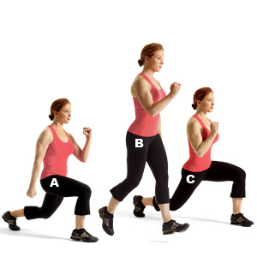
Duration of time or repetitions:
Complete 10 lunges on each side or twenty lunges total
Fitness ability worked on (speed, agility, strength etc):
This exercise enhances the participants strength in the legs
Sport or activity it would best suit or compliment (specificity):
This exercise would suit athletes in racquet sports or sports where athletes needs to stop and change direction quickly.

