SOLDIER Project Management Outline
You will have 1 class to complete each step. Any more time will need to be done as homework.
Step 1:
- Identify your problem: One side is arguing for a democratic style of governance while the other side supports tyranny- you must choose which side to support with your group of soldiers.

To help you understand these 2 forms of governance (and decide on your favorite), ask yourself the same question(s) about each type of governance.

- Gr 8: come up with 2 questions for each form of governance from each box on the Q Chart
- Gr 9: come up with 3 questions for each form of governance from each box on the Q Chart

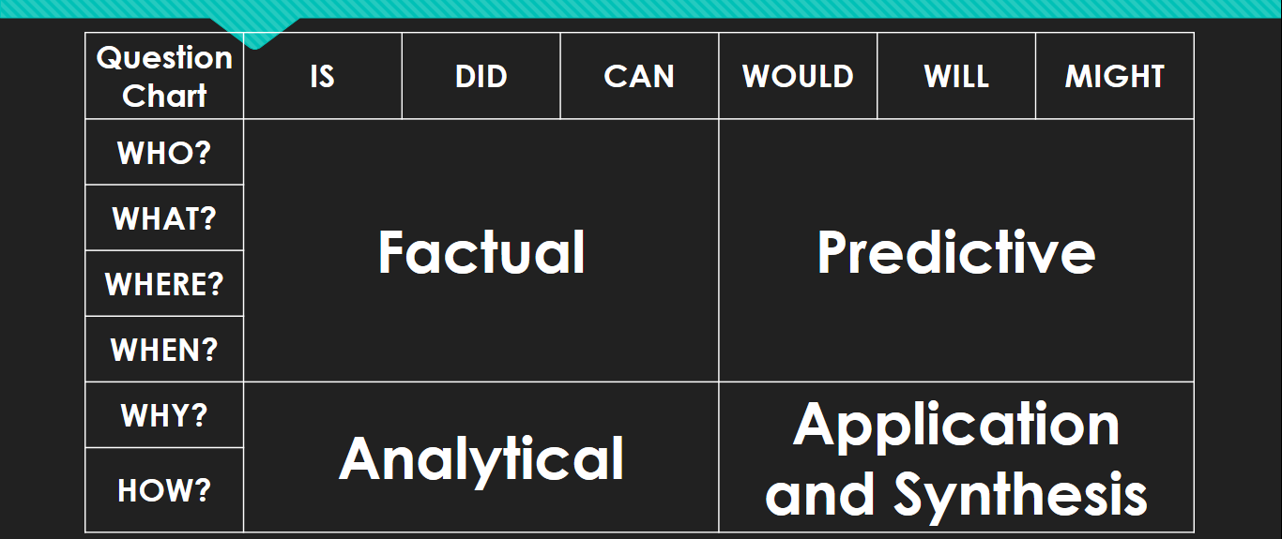

Ex (factual): What is democracy? AND What is Tyranny?, Who is in control with democracy AND who has control in Tyranny?= this is really 2 questions, the requirement for gr 8.

- Answer your questions

Questions & Answers (write you answers beside your question and remember to ask the question for both democracy and tyranny):

- ____________________________________________________________________________________________________________________________________________________________________________________________________________________________________

- ____________________________________________________________________________________________________________________________________________________________________________________________________________________________________

- ____________________________________________________________________________________________________________________________________________________________________________________________________________________________________

- ____________________________________________________________________________________________________________________________________________________________________________________________________________________________________

- ____________________________________________________________________________________________________________________________________________________________________________________________________________________________________

- ____________________________________________________________________________________________________________________________________________________________________________________________________________________________________

- ____________________________________________________________________________________________________________________________________________________________________________________________________________________________________

- ____________________________________________________________________________________________________________________________________________________________________________________________________________________________________

- ____________________________________________________________________________________________________________________________________________________________________________________________________________________________________

- ____________________________________________________________________________________________________________________________________________________________________________________________________________________________________

- ____________________________________________________________________________________________________________________________________________________________________________________________________________________________________

- ____________________________________________________________________________________________________________________________________________________________________________________________________________________________________

- ____________________________________________________________________________________________________________________________________________________________________________________________________________________________________

- ____________________________________________________________________________________________________________________________________________________________________________________________________________________________________

- ____________________________________________________________________________________________________________________________________________________________________________________________________________________________________

- ____________________________________________________________________________________________________________________________________________________________________________________________________________________________________

- ____________________________________________________________________________________________________________________________________________________________________________________________________________________________________

- ____________________________________________________________________________________________________________________________________________________________________________________________________________________________________

- _______________________________________________________________________________________________________________________________________________________________________________________________________________________________________
- ____________________________________________________________________________________________________________________________________________________________________________________________________________________________________

- ____________________________________________________________________________________________________________________________________________________________________________________________________________________________________

- _______________________________________________________________________________________________________________________________________________________________________________________________________________________________________

- ____________________________________________________________________________________________________________________________________________________________________________________________________________________________________

Step 2:
Step 2: Drawing from the questions and answers you created; decide which form of government your soldiers will support.

- Defend you choice in a one paragraph response. REMEMBER TO USE PROPER SPELLING AND PUNCTUATION. YOU WILL BE MARKED ON THESE.

________________________________________________________________________________________________________________________________________________________ ________________________________________________________________________________________________________________________________________________________
________________________________________________________________________________________________________________________________________________________
________________________________________________________________________________________________________________________________________________________
________________________________________________________________________________________________________________________________________________________
________________________________________________________________________________________________________________________________________________________
________________________________________________________________________________________________________________________________________________________
________________________________________________________________________________________________________________________________________________________
________________________________________________________________________________________________________________________________________________________
________________________________________________________________________________________________________________________________________________________
________________________________________________________________________________________________________________________________________________________
________________________________________________________________________________________________________________________________________________________
________________________________________________________________________________________________________________________________________________________
________________________________________________________________________________________________________________________________________________________
________________________________________________________________________________________________________________________________________________________
________________________________________________________________________________________________________________________________________________________
________________________________________________________________________________________________________________________________________________________
________________________________________________________________________________________________________________________________________________________

Step 3:
Step 3:
- You will need to design a flag that represents your colony.
Requirements:

- Using the colour symbolism guide on the provided website, choose a colour scheme that aligns with your colonies ideals. https://www.kids-world-travel-guide.com/flag-colors.html

- Include an image or shape that also represents the style of government you have chosen.

- Draw you flag below and describe the meaning of the colours, shapes, and symbols you used.

Step 4: BONUS
- Research the topic: “military coups in history”

- Choose a coup to read further into________________.

- How is this coup similar/different than the choice you made in deciding which government/leader to support.

- Provide your answer in the form of a paragraph.
__________________________________________________________________________________________________________________________________________________________

Day 1 |  | Day 2 |  | Day 3 |  | Day 4 |  | Day 5
Complete Q1 |  | Complete Q2 |  | Complete Q3 |  | Complete Q 4 BONUS |  | Upgrade your mark

The above table is to monitor your progress in this project. You need to have a team member review your work at the end of class and sign off on your work. This is to be done in the blank box. If you do not finish your work in class your team member will indicate how much you got done.
Example Below:
Day 1 |  | Day 2 |  | Day 3 |  | Day 4 |  | Day 5
Complete Q1 | JH  100% | Complete Q2 | JH %50 | Complete Q3 |  | Complete Q 4  BONUS |  | Upgrade your mark
*the example shows the person got 100% of Q1 done on Day 1. However on Day 2, they were distracted by youtube videos and only got %50 of Q2 done. When will they have time to complete this Question???

