SCOUT Project Management Outline
You will have 1 class to complete each step. Any more time will need to be done as homework.
Step 1:
- Identify your problem: you need to find a location for your colony to live. In order to determine where the best place to set up your colony is; first you must ask yourself a few questions.

- Gr 8: come up with 2-3 questions from each box on the Q Chart
- Gr 9: come up with 3-4 questions from each box on the Q Chart

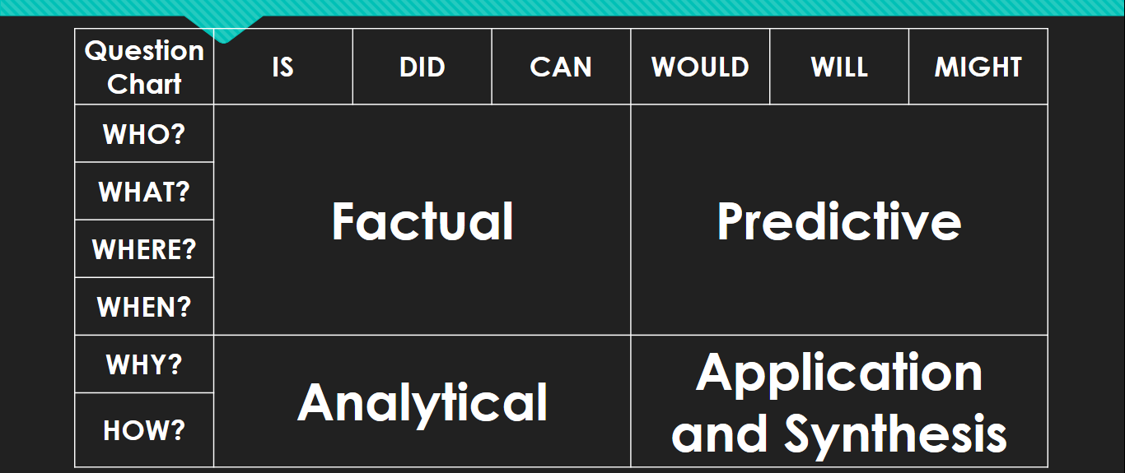

Ex: FACTUAL: what makes an area safe from attack A: high ground? PREDICTIVE: Where in the Comox Valley offers good high ground? A: valley view area, mount washington, apartment buildings ANALYTICAL: How can we use high ground to our advantage? A&S: How might living at mount washington be a burden on our colony?

- Answer your questions

Questions & Answers (write you answer in right after your question):

- ____________________________________________________________________________________________________________________________________________________________________________________________________________________________________
- ____________________________________________________________________________________________________________________________________________________________________________________________________________________________________
- ____________________________________________________________________________________________________________________________________________________________________________________________________________________________________
- ____________________________________________________________________________________________________________________________________________________________________________________________________________________________________
- ____________________________________________________________________________________________________________________________________________________________________________________________________________________________________
- ____________________________________________________________________________________________________________________________________________________________________________________________________________________________________
- ____________________________________________________________________________________________________________________________________________________________________________________________________________________________________
- ____________________________________________________________________________________________________________________________________________________________________________________________________________________________________
- ____________________________________________________________________________________________________________________________________________________________________________________________________________________________________
- ____________________________________________________________________________________________________________________________________________________________________________________________________________________________________
- ____________________________________________________________________________________________________________________________________________________________________________________________________________________________________
- ____________________________________________________________________________________________________________________________________________________________________________________________________________________________________
- ____________________________________________________________________________________________________________________________________________________________________________________________________________________________________
- ____________________________________________________________________________________________________________________________________________________________________________________________________________________________________
- ____________________________________________________________________________________________________________________________________________________________________________________________________________________________________
- ____________________________________________________________________________________________________________________________________________________________________________________________________________________________________
- ____________________________________________________________________________________________________________________________________________________________________________________________________________________________________
- ____________________________________________________________________________________________________________________________________________________________________________________________________________________________________
- _________________________________________________________________________________________________________________________________________________________

Step 2:
- Drawing from the questions and answers you created, decide on a location to set up your colony.

- Choose the most important features of a site and find it on google map. Must be in the Comox Valley.
- Print the screen and draw your colonies footprint on the page.

- Describe in one paragraph why you chose this location (strengths). Spelling and punctuation will be assessed: ________________________________________________________________________________________________________________________________________________________
________________________________________________________________________________________________________________________________________________________________________________________________________________________________________________________________________________________________________________________________________________________________________________________________________________________________________________________________________
____________________________________________________________________________________________________________________________________________________________________________________________________________________________________

- What are some weaknesses of your location?
____________________________________________________________________________________________________________________________________________________________________________________________________________________________________________________________________________________________________________________________________________________________________________________________________________________________________________________________________________________________________________________________________________________________________________________________________________________________________________________________________________________________________________________________________________________________________________________________________________________________________________________________________________________________________________________________________________________________________________________________________________________________________________________________________________________________________________________________________________________________________________________________________________________________________________________________________________________________________________________________________________________________________________________________________________________________________________________________________________________________________
____________________________________________________________________________________________________________________________________________________________________________________________________________________________________

Step 3:
- What resources will you need to build and maintain your colonies infrastructure needs? Ex: buildings, walls etc.
____________________________________________________________________________________________________________________________________________________________________________________________________________________________________
__________________________________________________________________________________________________________________________________________________________________________________________________________________________________________________________________________________________________________________________________________________________________________________________________________________________________________________________________________________________________________________________________________________________________________________________________________________________________________________________________________________________

- Create a list of places and locations in the Comox Valley where you will obtain your resources.
  - Include the distances and time to travel by foot to these locations from your site.
____________________________________________________________________________________________________________________________________________________________________________________________________________________________________
________________________________________________________________________________________________________________________________________________________________________________________________________________________________________________________________________________________________________________________________________________________________________________________________________________________________________________________________________
________________________________________________________________________________________________________________________________________________________________________________________________________________________________________________________________________________________________________________________________________________________________________________________________________________________________________________________________________
____________________________________________________________________________________________________________________________________________________________________________________________________________________________________

Step 4: BONUS
- Analyze the outcomes. Depending on how you attempted to solve the problem, you will be given a result of how your plans worked out.

- A final task will need to be completed to finish the job.

(Outcomes will be given to you by Mr. Hoy once you’ve completed and handed in Project Management questions 1-3).

*Example of an outcome: Your location is too far away from fresh water, your colonists begin to drink foul water and get sick.

- Make note of anything you can do better next time. Suggestions for your replacement in case you come down with the virus!

Day 1 |  | Day 2 |  | Day 3 |  | Day 4 |  | Day 5
Complete Q1 |  | Complete Q2 |  | Complete Q3 |  | Complete Q 4 BONUS |  | Upgrade your mark

The above table is to monitor your progress in this project. You need to have a team member review your work at the end of class and sign off on your work. This is to be done in the blank box. If you do not finish your work in class your team member will indicate how much you got done.
Example Below:
Day 1 |  | Day 2 |  | Day 3 |  | Day 4 |  | Day 5
Complete Q1 | JH  100% | Complete Q2 | JH %50 | Complete Q3 |  | Complete Q 4  BONUS |  | Upgrade your mark
*the example shows the person got 100% of Q1 done on Day 1. However on Day 2, they were distracted by youtube videos and only got %50 of Q2 done. When will they have time to complete this Question???

