MEDIC Project Management Outline
You will have 1 class to complete each step. Any more time will need to be done as homework.
Step 1:
- Identify your problem: we have too many zombie corpses lying around the fence of our colony.

- Gr 8: come up with 2-3 questions from each box on the Q Chart
- Gr 9: come up with 3-4 questions from each box on the Q Chart
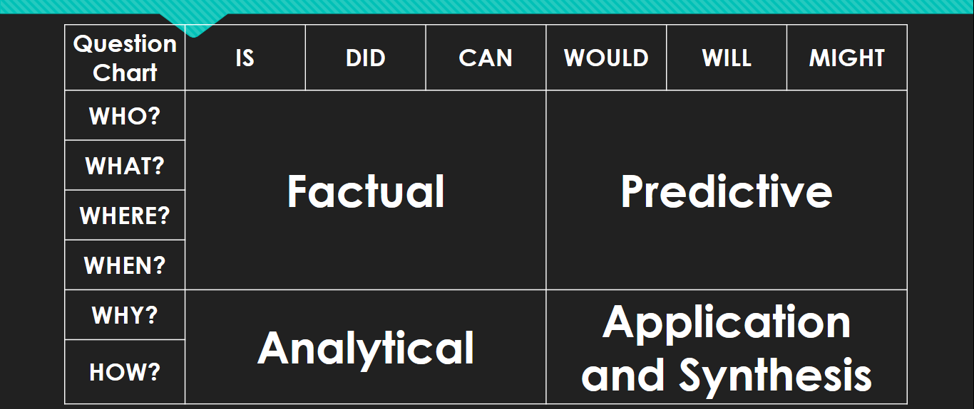

Ex: FACTUAL: what kind of diseases do dead bodies spread? PREDICTIVE: where might we dispose of these bodies? ANALYTICAL: How can we prevent bodies from building up at the fence? A&S: How might the smell of decay affect the colonies morale?

- Answer your questions

Questions & Answers (write you answer in right after your question):

- ____________________________________________________________________________________________________________________________________________________________________________________________________________________________________
- ____________________________________________________________________________________________________________________________________________________________________________________________________________________________________
- ____________________________________________________________________________________________________________________________________________________________________________________________________________________________________
- ____________________________________________________________________________________________________________________________________________________________________________________________________________________________________
- ____________________________________________________________________________________________________________________________________________________________________________________________________________________________________
- ____________________________________________________________________________________________________________________________________________________________________________________________________________________________________
- ____________________________________________________________________________________________________________________________________________________________________________________________________________________________________
- ____________________________________________________________________________________________________________________________________________________________________________________________________________________________________
- ____________________________________________________________________________________________________________________________________________________________________________________________________________________________________
- ____________________________________________________________________________________________________________________________________________________________________________________________________________________________________
- ____________________________________________________________________________________________________________________________________________________________________________________________________________________________________
- ____________________________________________________________________________________________________________________________________________________________________________________________________________________________________
- ____________________________________________________________________________________________________________________________________________________________________________________________________________________________________
- ____________________________________________________________________________________________________________________________________________________________________________________________________________________________________
- ____________________________________________________________________________________________________________________________________________________________________________________________________________________________________
- ____________________________________________________________________________________________________________________________________________________________________________________________________________________________________
- ____________________________________________________________________________________________________________________________________________________________________________________________________________________________________
- ____________________________________________________________________________________________________________________________________________________________________________________________________________________________________
- ____________________________________________________________________________________________________________________________________________________________________________________________________________________________________

Step 2:
- Drawing from the questions and answers you created, come up with a game plan to solve the problem presented to you.

- Create a list of items/equipment you will need to complete the mission. Include where to get items.

________________________________________________________________________________________________________________________________________________________ ________________________________________________________________________________________________________________________________________________________
________________________________________________________________________________________________________________________________________________________
________________________________________________________________________________________________________________________________________________________
________________________________________________________________________________________________________________________________________________________
________________________________________________________________________________________________________________________________________________________
________________________________________________________________________________________________________________________________________________________
________________________________________________________________________________________________________________________________________________________
________________________________________________________________________________________________________________________________________________________
________________________________________________________________________________________________________________________________________________________
________________________________________________________________________________________________________________________________________________________
________________________________________________________________________________________________________________________________________________________
________________________________________________________________________________________________________________________________________________________
________________________________________________________________________________________________________________________________________________________
________________________________________________________________________________________________________________________________________________________
________________________________________________________________________________________________________________________________________________________
________________________________________________________________________________________________________________________________________________________
________________________________________________________________________________________________________________________________________________________

Step 3:
- Step 3: Create a step-by-step list of actions needed to do the job right. The list should be very simple and straight forward so your assistants to carry out your plan. Like a recipe! Ex: Step 1:…..
Step 2:….
____________________________________________________________________________________________________________________________________________________________________________________________________________________________________
______________________________________________________________________________________________________________________________________________________________________________________________________________________________________________________________________________________________________________________________________________________________________________________________________________________________________________________________________________________________________________________________________________________________________________________________________________________________________________________________________________________________________________________________________________________________________________________________________________________________________________________________________________________________________________________________
________________________________________________________________________________________________________________________________________________________________________________________________________________________________________________________________________________________________________________________________________________________________________________________________________________________________________________________________________
________________________________________________________________________________________________________________________________________________________________________________________________________________________________________________________________________________________________________________________________________________________________________________________________________________________________________________________________________
____________________________________________________________________________________________________________________________________________________________________________________________________________________________________

- Remember you are the head of your department, the tasks will be delegated (given to) your assistants. It needs to read clearly so they will not make a mistake.

Step 4: BONUS
- Analyze the outcomes. Depending on how you attempted to solve the problem, you will be given a result of how your plans worked out.

- A final task will need to be completed to finish the job.

(Outcomes will be given to you by Mr. Hoy once you’ve completed and handed in Project Management questions 1-3).

*Example of an outcome: You did not bury the corpses deep enough and bears got into the pits- now you have ZOMBIE BEARS!!!

- Make note of anything you can do better next time. Suggestions for your replacement in case you come down with the virus!

Day 1 |  | Day 2 |  | Day 3 |  | Day 4 |  | Day 5
Complete Q1 |  | Complete Q2 |  | Complete Q3 |  | Complete Q 4 BONUS |  | Upgrade your mark

The above table is to monitor your progress in this project. You need to have a team member review your work at the end of class and sign off on your work. This is to be done in the blank box. If you do not finish your work in class your team member will indicate how much you got done.
Example Below:
Day 1 |  | Day 2 |  | Day 3 |  | Day 4 |  | Day 5
Complete Q1 | JH  100% | Complete Q2 | JH %50 | Complete Q3 |  | Complete Q 4  BONUS |  | Upgrade your mark
*the example shows the person got 100% of Q1 done on Day 1. However on Day 2, they were distracted by youtube videos and only got %50 of Q2 done. When will they have time to complete this Question???

