- Sustainability: ________________________________________________________________________________________________________________________________________________________________________________________________________________________

- Looking at a topic through a certain “lens” lets us analyse the issue from different perspectives or points of view.

- 1. Economic lens: ________________________________________________________?
- Example: A Tree (through the lens of “economy”): this tree is worth $20,000 if we cut it, turn it into lumber, and sell it.

- 2. Society: ______________________________________________________________ _______________________________________________________________________________________________________________________________________________?
- Ex: A tree might be sacred to some people. Or walking through the woods might be a hobby for others

- 3 environmental: ________________________________________________________ _______________________________________________________________________?
- Ex: a tree is habitat for many animals
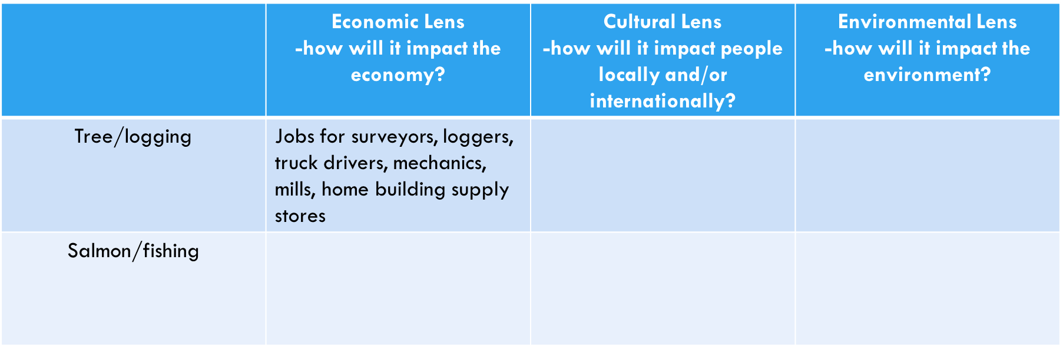

The 4 spheres

- Lithosphere: _____________________________________________________________ ________________________________________________________________________

- Hydrosphere: ____________________________________________________________ ________________________________________________________________________
- Liquid, solid, and vapor are all the states of the hydrosphere

- Atmosphere- The gasses that surround the earth. They are held in place by gravity.
- Composed of:
- _________________________________________
- _________________________________________
- _________________________________________

- The make up of the lithosphere, atmosphere, and hydrosphere are all ____________ _____________________________________ (air, water, rock)

- When the right conditions of these factors merge, life can exist. We call this area of the planet the __________________________.

- Biosphere: ______________________________________________________________ _______________________________________________________________________ _______________________________________________________________________.

- ____________________________________________: any living thing in an ecosystem.

